Table 1- Main sociodemographic characteristics of parents and children and their relationship with blood lead levels.
Sociademographic characteristics of the children, parents and their surroundings | Number§/  Mean | Blood lead level (µg/dL) | p
- Gender (n): • Boys  • Girls | 297  214 | 3.9 (0.2)  3.7 (0.2) | 0.087
- Age (months, SD*): | 92.0 (4.8) | -0.09 | 0.003
- Home address: • City of Madrid  • Corona Metropolitana | 298  213 | 4.0 (0.1)  3.5 (0.2) | 0.000
- Nursery/preschool attendance (n): • Yes  • No | 458  52 | 3.8 (0.2)  3.7 (0.2) | n.s.
- Nursery/preschool attendance (years, SD): | 2.4 (1.3) | 0.04 | n.s.
- Use of School Cafeteria (n): • Yes  • No | 126  215 | 4.0 (0.2)  3.9 (0.2) | n.s.
- Age (years, SD): • Fathers  • Mothers | 42.8 (16.8)  37.8 (12.4) | 0.04  0.00 | n.s.  n.s.
- Educational level (n):
● Fathers: • Illiterate/ Primary Ed. or Incomplete Sec. Ed.  • Equiv. Junior High School/Vocational Training Level 1  • Equiv. High School Graduate/ VT Level 2  • University Graduate | 74  218  80  86 | 3.9 (0.1)  3.8 (0.2)  3.5 (0.1)  3.9 (0.1) | n.s.
● Mothers: • Illiterate/ Primary Ed. or Incomplete Sec. Ed.  • Equiv. Junior High School/Vocational Training Level 1  • Equiv. High School Graduate/ VT Level 2.  • University Graduate | 93  244  93  56 | 4.1 (0.1)  3.7 (0.2)  3.8 (0.1)  3.7 (0.1) | n.s.
- Employment situation (n):
● Fathers: • Actively employed  • Unemployed/ retired/ disability pension/ housework | 438  30 | 3.8 (0.1)  3.9 (0.1) | n.s.
● Mothers: • Actively employed  • Unemployed/ retired/ disability pension/ housework | 179  313 | 3.8 (0.1)  3.8 (0.1) | n.s.
- Tobacco Smoking (n):
● Fathers: • Non-smoker (including ex-smokers)  • Smokers | 192  278 | 3.9 (0.1)  3.6 (0.1) | 0.089
● Mothers: • Non-smoker (including ex-smokers)  • Smokers | 241  251 | 3.9 (0.1)  3.7 (0.1) | 0.081
- Pets:
● Dogs: • Yes  • No | 59  442 | 3.8 (0.2)  3.8 (0.1) | n.s.
● Cats: • Yes  • No | 32  468 | 3.2 (0.2)  3.8 (0.1) | 0.010
● Others: • Yes  • No | 218  286 | 3.7 (0.1)  3.9 (0.1) | n.s.
§ = In the numerical breakdowns, up to n=511 belong to the category “unknown”.
* = Standard deviation
Table 2- Relationship between blood lead levels and the sociodemographic variables, according to the teachers’ assessment of behavior and academic achievements.
Sociodemographic variables of the children and parents | Behavioral assessment |  |  |  | Assessment of academic achievement
Sociodemographic variables of the children and parents | Finishing of tasks | Ease of distraction | Restlessness when seated | Restless behavior | Reading comprehension | Oral expression | Writing ability | Mathematics
Blood lead levels (in µg/dL(r)‡: | -0.07 | 0.07 | 0.10** | 0,07 | -0.13*** | -0.06* | -0.10** | -0.11**
Age (in months)(r)‡: | 0.14*** | -0.05 | -0.05 | -0.03 | 0.12*** | 0.11** | 0.09** | 0.12***
- Gender (SD*): • Boys  • Girls | 3.74 (1.16)***  4.90 (1.09) | 3.06 (1.00)***  2.78 (0.96) | 2.68 (1.01)***  2.25 (0.99) | 2.49 (1.02)***  2.10 (1.03) | 3.54 (1.10)*  3.69 (0.94) | 3.35 (1.00)**  3.54 (0.88) | 3.18 (1.09)***  3.64 (0.96) | 3.48 (1.03)  3.50 (0.94)
- Residence: • City of Madrid  • Corona Metropolitana | 3.74 (1.10)***  4.05 (1.17) | 3.06 (0.88)***  2.78 (1.12) | 2.61 (0.93)***  2.34 (1.12) | 2.28 (0.97)***  2.12 (1.10) | 3.41 (0.99)***  3.86 (1.06) | 3.24 (0.86)***  3.69 (1.01) | 3.21 (1.01)***  3.60 (1.10) | 3.34 (0.99)***  3.69 (0.96)
- Nursery/preschool attendance (SD)¶: • Yes  • No | 3.86 (1.15)  4.02 (1.04) | 2.96 (0.98)  2.77 (1.11) | 2.52 (1.02)  2.31 (1.11) | 2.34 (1.04)  2.17 (1.04) | 3.60 (1.03)  3.65 (1.10) | 3.44 (0.94)  3.38 (1.01) | 3.38 (1.05)  3.38 (1.12) | 3.50 (0.99)  3.44 (1.02)
- Nursery/preschool attendance (years. r): | -0.10** | 0.06 | 0.16*** | 0.11** | -0.05 | -0.01 | -0.06 | 0.02
- Use of School Cafeteria (SD): • Yes  • No | 3.77 (1.10)  3.81 (1.13) | 3.10 (0.95)  3.03 (0.98) | 2.59 (1.00)  2.72 (0.98) | 2.51 (1.04)  2.61 (1.01) | 3.35 (0.96)  3.47 (1.07) | 3.27 (0.88)  3.24 (0.89) | 3.18 (0.96)  3.18 (1.04) | 3.19 (0.92)  3.45 (1.03)**
- Age of parents (r): • Fathers  • Mothers | 0.07  0.09** | -0.12***  -0.11** | -0.21***  -0.19*** | -0.13***  -0.14*** | 0.09**  0.05 | 0.10**  0.06 | 0.10**  0.13*** | 0.10**  0.08*
- Educational level (r): • Fathers  • Mothers | 0.16***  0.11** | -0.14***  -0.12*** | -0.14***  -0.11** | -0.15***  -0.12*** | 0.06  0.08* | 0.11**  0.11** | 0.17***  0.14*** | 0.19***  0.20***
- Employment situation (SD):
● Fathers: • Actively employed  • Unemployed/housework | 3.90 (1.13)  3.90 (1.35) | 2.90 (1.00)  2.97 (1.03) | 2.47 (1.02)  2.33 (1.09) | 2.30 (1.04)  2.23 (1.19) | 3.68 (1.02)  3.30 (1.24)* | 3.48 (0.94)  3.20 (1.06) | 3.42 (1.06)  3.37 (1.22) | 3.55 (0.99)  3.40 (1.07)
● Mothers: • Actively employed  • Unemployed/housework | 3.94 (1.05)  3.84 (1.18) | 2.88 (0.95)  2.96 (1.02) | 2.39 (1.00)  2.52 (1.04) | 2.20 (1.00)  2.38 (1.06)* | 3.65 (0.96)  3.62 (1.07) | 3.44 (0.92)  3.47 (0.95) | 3.45 (1.03)  3.36 (1.09) | 3.54 (1.01)  3.47 (0.99)
- Tobacco smoking of parents (SD):
● Fathers: • Yes  • No | 3.82 (1.15)  4.02 (1.12)* | 2.96 (0.99)  2.80 (1.01)* | 2.56 (1.02)  2.32 (1.01)** | 2.40 (1.05)  2.14 (1.04)*** | 3.58 (1.07)  3.78 (0.97)** | 3.39 (0.95)  3.59 (0.93)** | 3.31 (1.09)  3.57 (1.01)*** | 3.42 (1.00)  3.71 (0.97)***
● Mothers: • Yes  • No | 3.74 (1.19)  4.01 (1.07)*** | 3.03 (1.00)  2.82 (0.98)** | 2.60 (1.04)  2.34 (0.99)*** | 2.39 (1.06)  2.22 (1.02) | 3.57 (1.10)  3.68 (0.94) | 3.41 (0.97)  3.47 (0.90) | 3.27 (1.11)  3.51 (1.00)** | 3.40 (1.05)  3.58 (0.94)*
- Pets (SD):
● Dogs: • Yes  • No | 3.59 (1.07)  3.91 (1.15)** | 3.20 (0.94)  2.89 (0.99)** | 2.66 (0.92)  2.46 (1.03) | 2.66 (1.08)  2.27 (1.03)*** | 3.19 (1.12)  3.67 (1.01)*** | 3.10 (1.06)  3.49 (0.92)*** | 2.98 (1.03)  3.44 (1.05)*** | 3.19 (1.04)  3.53 (0.98)**
● Cats: • Yes  • No | 3.90 (1.15)  3.62 (1.07) | 3.09 (1.06)  2.92 (0.99) | 2.78 (1.01)  2.47 (1.03)* | 2.59 (0.98)  2.30 (1.04) | 3.38 (1.29)  3.64 (1.01) | 3.34 (1.13)  3.46 (0.93) | 3.19 (1.12)  3.40 (1.05) | 3.44 (1.16)  3.50 (0.98)
● Others: • Yes  • No | 4.01 (1.09)  3.68 (1.19)*** | 3.05 (1.03)  2.85 (0.96)** | 2.67 (1.04)  2.36 (0.99)*** | 2.45 (1.07)  2.23 (1.02)** | 3.48 (1.07)  3.72 (0.98)*** | 3.36 (0.95)  3.51 (0.94)* | 3.22 (1.08)  3.51 (1.03)*** | 3.35 (1.02)  3.60 (0.96)***
‡ = Correlation coefficients (r): Spearman for the variables of behavioral assessment and Pearson for the variables for academic achievement.
SD = Standard deviation
* = p≤0.10; ** = p≤0,05; *** = p≤0,01
Table 3.- Multiple regression analysis of the blood lead levels of the children in relation to the teachers’ assessments of behavior and academic achievement, controlling for sociodemographic variables. Expression of regression coefficients.
 | Significance of the teachers’ assessment parameters
 | Behavioral assessment |  |  |  |  | Assessment of academic achievement
 | Finishing of tasks | Ease of distraction | Difficulties keeping still when seated | Restless behavior | Overall behavior | Reading comprehen-sion | Oral expression | Writing ability | Mathematics | Overall academic achievement
- Blood lead level | -0.032 | 0.024 | 0.020 | 0.036 | -0.112 | -0.058* | -0.001 | -0.044 | -0.054* | -0.158
- Age (in months): | 0.027** | -0.013 | -0.007 | -0.019* | 0.052 | 0.011 | 0.007 | 0.018* | 0.007 | 0.044
- Gender | -0.218** | 0.256*** | 0.300*** | 0.357*** | -1.131*** | -0.083 | -0.160* | -0.410*** | 0.048 | -0.605*
- Residence (City of Madrid and Corona Metropolitana) | -0.210* | 0.376*** | 0.503*** | 0.375*** | -1.464*** | -0.566*** | -0.559*** | -0.485*** | -0.495*** | -2.104***
- Nursery/preschool attendance (yes/no): | 0.024 | 0.144 | 0.125 | 0.007 | -0.252 | -0.054 | 0.039 | 0.008 | -0.108 | -0.115
- Nursery/preschool attendance (years) | -0.108* | 0.038 | 0.073** | 0.122** | -0.340** | -0.018 | 0.019 | 0.004 | 0.065 | 0.064
- Age of parents (years):
• Fathers | 0.008 | -0.018 | 0.000 | -0.020 | 0.046 | 0.036** | 0.027** | 0.012 | 0.028** | 0.103**
• Mothers | -0.006 | 0.009 | -0.017 | -0.009 | 0.011 | -0.034** | -0.025* | -0.007 | -0.023 | -0.088
- Educational level (4-level scale):
• Fathers | 0.178** | -0.105 | -0.120* | -0.110* | 0.514** | 0.015 | 0.045 | 0.143** | 0.150** | 0.353
• Mothers | 0.048 | -0.095 | -0.038 | -0.053 | 0.234 | 0.108 | 0.133* | 0.106 | 0.113 | 0.460*
- Employment situation (actively employed/ unemployed):
• Fathers: | 0.103 | 0.056 | -0.122 | -0.119 | 0.288 | -0.214 | -0.098 | 0.050 | -0.004 | -0.265
• Mothers: | -0.019 | 0.009 | 0.140 | 0.068 | -0.236 | -0.037 | 0.098 | 0.028 | 0.062 | 0.150
- Tobacco smoking (yes/no):
• Fathers: | -0.045 | 0.053 | 0.119 | 0.128 | -0.346 | -0.046 | -0.075 | -0.078 | -0.101 | -0.301
• Mothers: | -0.024 | 0.018 | -0.042 | -0.054 | -0.054 | -0.024 | 0.019 | -0.027 | -0.020 | -0.013
- Pets (yes/no):
• Dogs: | -0.336* | 0.352** | 0.375** | 0.228 | -1.290** | -0.463*** | -0.426*** | -0.472*** | -0.391*** | -1.752***
• Cats: | -0.194 | -0.034 | 0.205 | 0.084 | -0.450 | -0.083 | -0.011 | 0.038 | -0.090 | -0.116
• Other pets: | -0.330*** | 0.171* | 0.180* | 0.253*** | -0.935*** | -0.255*** | -0.163* | -0.273*** | -0.243** | -0.934***
n=430
* = p≤0,10; ** = p≤0,05; *** = p≤0,01

Table 4- Discrimination between various blood lead levels in children as cut-offs in the detection of differences in the teachers’ assessments of behavior and academic achievement.

 | Assessment parameters
 | Overall assessment of behavior (SD) | p value | Overall assessment of academic achievement (SD) | p value
- Cut-off at 30 µg/L
- <30 µg/L (n= 104)  - ≥30 µg/L (n= 407) | -3.96 (3.77)  -3.88 (3.43) | n.s. | 13.97 (3.54)  13.87 (3.64) | n.s.
- Cut-off at 40 µg/L
- <40 µg/L (n= 256)  - ≥40 µg/L (n= 255) | -3.54 (3.58)  -3.90 (3.49) | 0.020 | 14.34 (3.48)  13.44 (3.71) | 0.005
- Cut-off at 50 µg/L
- <50 µg/L (n= 386)  - ≥50 µg/L (n= 125) | -3.80 (3.54)  -4.22 (3.33) | n.s. | 14.19 (3.59)  12.97 (3.57) | 0.001
- Cut-off at 60 µg/L
- <60 µg/L (n= 456)  - ≥60 µg/L (n= 55) | -3.78 (3.49)  -4.93 ( 3.34) | 0.021 | 14.01 (3.59)  12.89 (3.70) | 0.030
- Cut-off at 70 µg/L
- <70 µg/L (n= 490)  - ≥70 µg/L (n= 21) | -3.86 (3.51)  -4.95 (3.14) | n.s. | 13.93 (3.62)  13.10 (3.46) | n.s.

Figure 1- Blood lead levels of 7-8 year old children of the Madrid Region (with 95% Cl) and the teachers’ assessment parameters for behavior and academic achievement.
Blood lead levels and teachers’ assessment of behavior

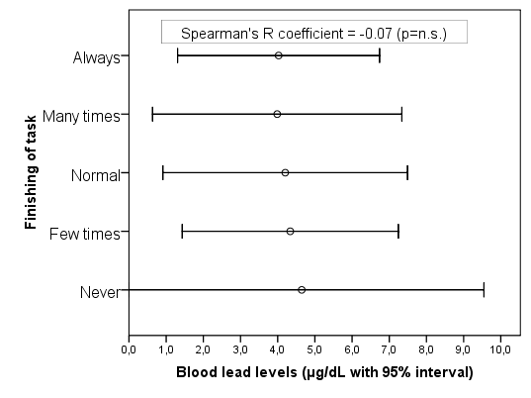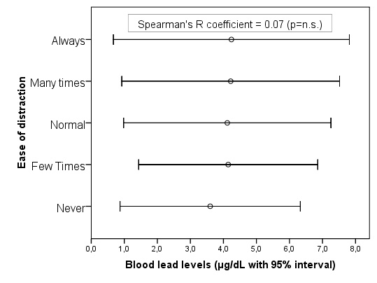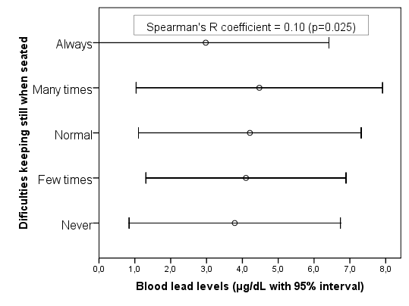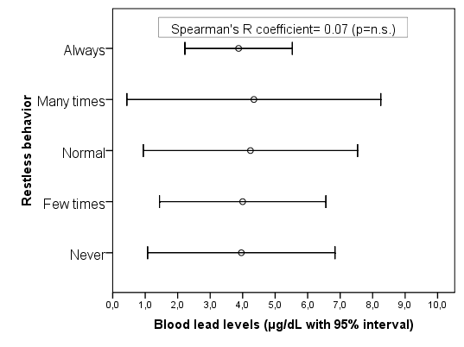

Blood lead levels and teachers’ assessment of academic achievement

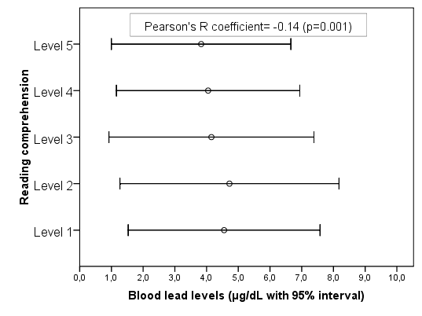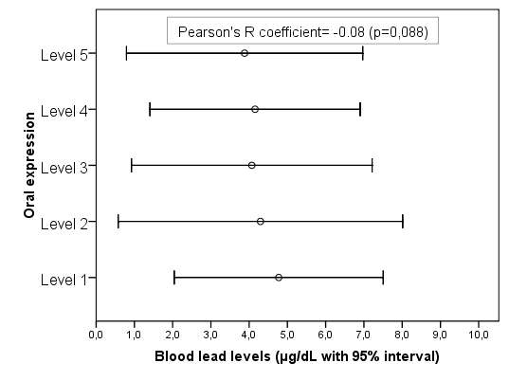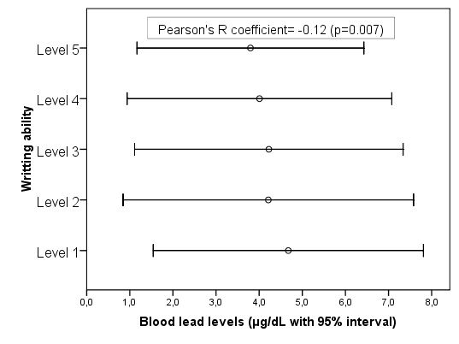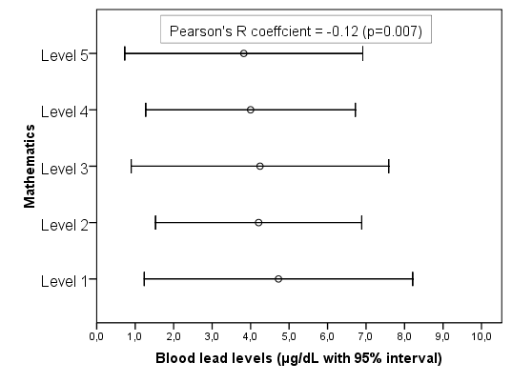
Correlation coefficients: p value in brackets.

Figure 2- Relationship of the blood lead levels of 7-8 year old children in the Madrid Region with the teachers’ overall assessment parameters for behavior and academic achievement. Straight-line adjustment with 95% Cl and correlation coefficients.
Blood lead levels and teachers’ overall assessment

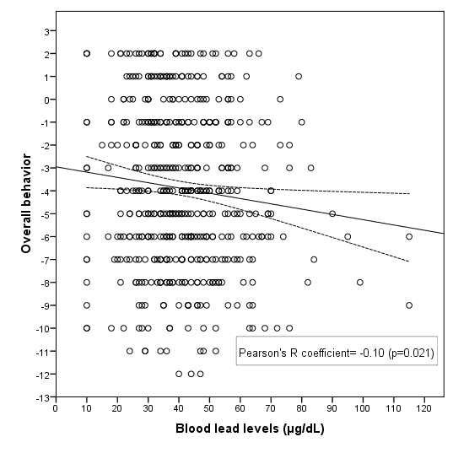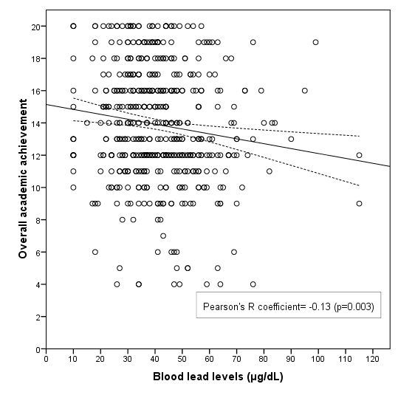

Left-hand figure, Overall assessment of behavior = Value for finishing tasks – Ease of distraction – Difficulties in keeping still – Restless behavior.
Right-hand figure, Overall assessment of academic achievement = Reading comprehension + Oral expression + Writing ability + Mathematics.
Correlation coefficients: p value in brackets. Straight-line regression with 95%

